MOSAICS project: what’s on-the-go?

The MOSAICS project has picked up a great deal of momentum since the four Early Stage Researchers started in February 2020!

The first paper of the MOSAICS project was recently published by Loes Beckers! The paper is titled “Exploring neurocognitive factors and brain activation in adult cochlear implant recipients associated with speech perception outcomes – a scoping review” and was a great collaboration with MOSAICS supervisors and co-researcher, Nikki Philpott (Tromp). Loes created an engaging video abstract about her paper, which can be watched here.

As part of his research into auditory nerve conditions, Ignacio Calderón has been analyzing reaction time data from CI recipients in his experiments. In gaining insights into how the auditory nerve responds to signals from the implant, he hopes the information can ultimately facilitate recipients getting the most from their CIs.

The AuDiET clinical study (presented at the EURO-CIU symposium at the end of 2020) involving Enrico Migliorini and Nikki Philpott is actively ongoing. The whole team is committed to laying a strong foundation for personalized, evidence-based fitting and auditory rehabilitation for adult CI users.

Overall, these projects are helping us gain greater insights into outcome variability, what contributes to it and what factors we can consider to address it. Learnings from all four research projects will be shared at scientific conferences and symposiums throughout 2023, but keep an eye on our MOSAICS website or follow @MOSAICS_2020 on Twitter for more frequent updates.

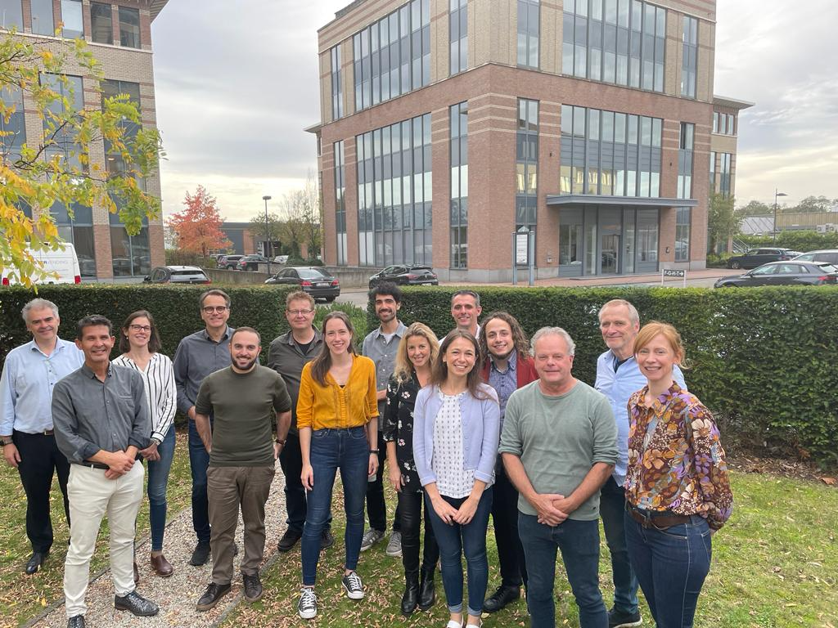

Photo caption: The MOSAICS core team recently gathered for the MOSAICS Research Days Mechelen, Belgium at the end of 2020.

Back row (left to right): Filiep Vanpoucke, Emily Rose Ciscato, Joerg Pesch, Marc van Wanrooij, Ignacio Calderón, Tom Bertens, Enrico Migliorini, John van Opstal

Front row (left to right): Andy Beynon, Marco Cavallaro, Loes Beckers, Wendy Huinck, Nikki Philpott, Emmanuel Mylanus, Birgit Philips

