

**DAY 1**

**THURSDAY 16TH OCTOBER 2025**

****8.30 Registration/ Coffee / Exhibition

**9.30 Welcome: Leo De Raeve, Chair, CIICA & Founding Members**

**Rob Beenders, Minister of Consumer Affairs, Social Fraud & Equal Opportunities in Belgium**

**Zala Tomasic, MEP, Politicians meeting Experience**

**Shelly Chadha, Sensory functions, Disability, and Rehabilitation, WHO**

**Graeme Clark, Professor of Otolaryngology, University of Melbourne**

**10.15 SLIDO: Who are you? Daniel Aplas**

10.30 Coffee

**11.00 Influencing governments**

**12.00 CIICA Collaborations – the network’s impact**

12.30 Lunch and Exhibition : activities and discussions

**13.30 CIICA: Where Science Meets Experience**

14.30 Coffee and Exhibition

**15.30 CI in LMIC – Carolina Der, WHO, plus contributions**

**16.45 SLIDO discussion and quiz**

**17.00 CLOSE**

**19.00 Networking Dinner**

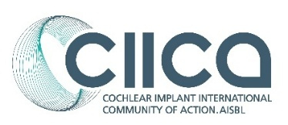



**DAY 2**

**FRIDAY 17TH OCTOBER 2025**



**9.00 SLIDO : Good morning..**

**9.10 Parents as Advocates**

**10.15 Young adults Agenda For Change**

10.45 Coffee and Exhibition

**11.15 Adults: Lifelong Services**

12.45 Lunch and Exhibition: activities and discussions

**13.45 Sustainable CI services: delivering services differently**

15.00 Coffee and Exhibition

**15:30 Advocacy: what do we need? Resources and evidence**

**16.30 Summary: Future collaborations: SLIDO : What are you doing on Monday?**

**16.45 CLOSE: Leo De Raeve**

